Experiment 7

AIM: to design a protype of an automatic vending machine for drinks

procedure:

1. Define the document type and HTML root element.
2. Set the page title and include CSS styles.
3. Create a container for centering the content.
4. Display the title
5. Create a form with input fields and a submit button.
6. Close the form, container, body, and HTML tags.

code:

<!DOCTYPE html>

<html>

<head>

<title>Automatic Vending Machine</title>

<style>

body{font-family:Arial,sans-serif;background-color:#f2f2f2}.container{margin:50px auto;width:400px;text-align:center;padding:20px;background-color:#fff;border-radius:5px;box-shadow:0 0 10px rgba(0,0,0,.1)}.button{display:inline-block;padding:10px 20px;margin:10px;background-color:#4CAF50;color:#fff;text-decoration:none;border-radius:4px;transition:background-color .3s}.button:hover{background-color:#45a049}

</style>

</head>

<body>

<div class="container">

<h1>Automatic Vending Machine</h1>

<p>Select your drink:</p>

<button class="button">Coca-Cola</button>

<button class="button">Pepsi</button>

<button class="button">Sprite</button>

<button class="button">Fanta</button>

<p>Payment Options:</p>

<button class="button">Credit Card</button>

<button class="button">Mobile Payment</button>

<p>Thank you for using the vending machine!</p>

</div>

</body>

</html>

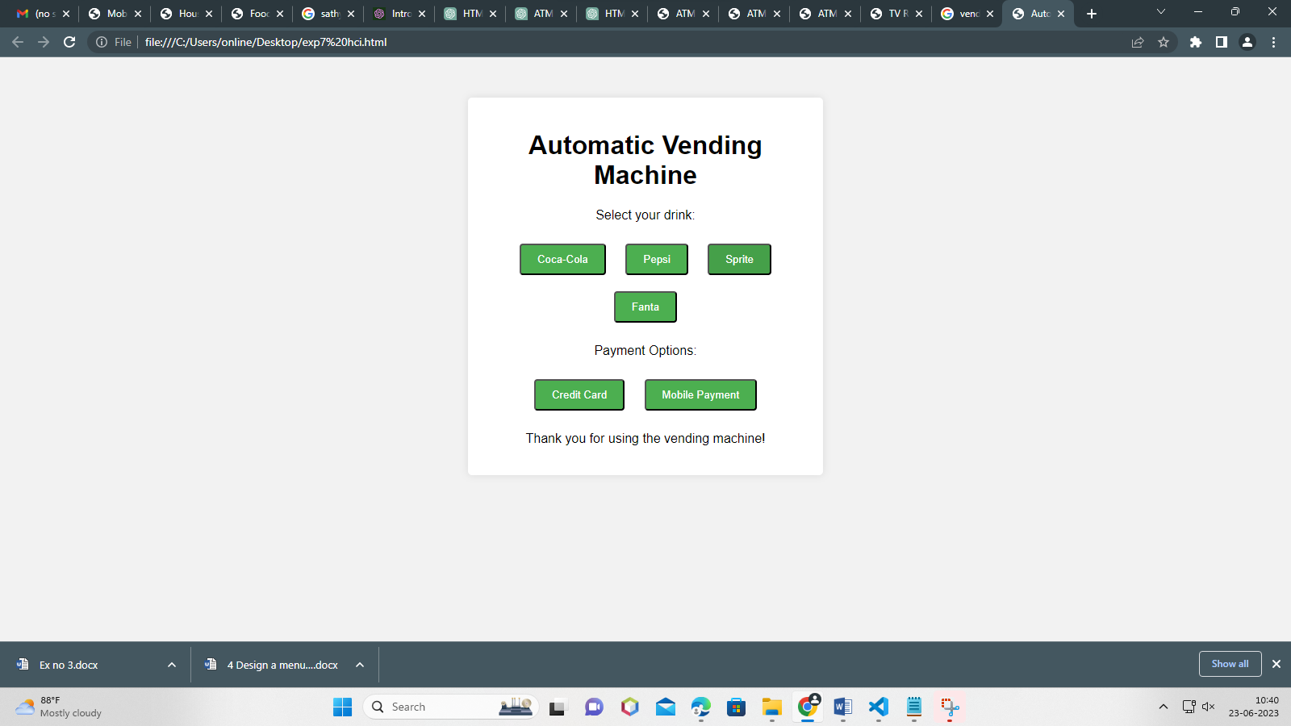

result:

thus,the design a protype of an automatic vending machine for drinks implemented successfully